

Semester Two Examination, 2021

Question/Answer booklet

MATHEMATICS  
SPECIALIST  
UNITS 1&2

Section Two:  
Calculator-assumed

Teacher

Your name

|  |  |
| --- | --- |
| Number of additional answer booklets used (if applicable): |  |

## Time allowed for this section

Reading time before commencing work: ten minutes

Working time: one hundred minutes

## Materials required/recommended for this section

***To be provided by the supervisor***

This Question/Answer booklet

Formula sheet (retained from Section One)

***To be provided by the candidate***

Standard items: pens (blue/black preferred), pencils (including coloured), sharpener,  
correction fluid/tape, eraser, ruler, highlighters

Special items: drawing instruments, templates, notes on two unfolded sheets of A4 paper, and up to three calculators, which can include scientific, graphic and Computer Algebra System (CAS) calculators, are permitted in this ATAR course examination

## Important note to candidates

No other items may be taken into the examination room. It is **your** responsibility to ensure that you do not have any unauthorised material. If you have any unauthorised material with you, hand it to the supervisor **before** reading any further.

## Structure of this paper

|  |  |  |  |  |  |
| --- | --- | --- | --- | --- | --- |
| Section | Number of questions available | Number of questions to be answered | Working time (minutes) | Marks available | Percentage of examination |
| Section One: Calculator-free | 8 | 8 | 50 | 50 | 35 |
| Section Two: Calculator-assumed | 13 | 13 | 100 | 92 | 65 |
|  | | |  | **Total** | 100 |

|  |  |  |
| --- | --- | --- |
| Markers use only | | |
| Question | Maximum | Mark |
| 9 | 6 |  |
| 10 | 7 |  |
| 11 | 7 |  |
| 12 | 8 |  |
| 13 | 8 |  |
| 14 | 7 |  |
| 15 | 6 |  |
| 16 | 8 |  |
| 17 | 7 |  |
| 18 | 7 |  |
| 19 | 7 |  |
| 20 | 7 |  |
| 21 | 7 |  |
| S2 Total | 92 |  |
| S2 Wt (×0.7065) | 65% |  |

## Instructions to candidates

1. The rules for the conduct of examinations are detailed in the school handbook. Sitting this examination implies that you agree to abide by these rules.

2. Write your answers in this Question/Answer booklet preferably using a blue/black pen.  
Do not use erasable or gel pens.

3. You must be careful to confine your answers to the specific question asked and to follow any instructions that are specific to a particular question.

4. Show all your working clearly. Your working should be in sufficient detail to allow your answers to be checked readily and for marks to be awarded for reasoning. Incorrect answers given without supporting reasoning cannot be allocated any marks. For any question or part question worth more than two marks, valid working or justification is required to receive full marks. If you repeat any question, ensure that you cancel the answer you do not wish to have marked.

5. It is recommended that you do not use pencil, except in diagrams.

6. Supplementary pages for planning/continuing your answers to questions are provided at the end of this Question/Answer booklet. If you use these pages to continue an answer, indicate at the original answer where the answer is continued, i.e. give the page number.

7. The Formula sheet is not to be handed in with your Question/Answer booklet.

Section Two: Calculator-assumed 65% (92 Marks)

This section has**thirteen** questions. Answer **all** questions. Write your answers in the spaces provided.

Working time: 100 minutes.

Question 9 (6 marks)

(a) Determine the vector projection of $\left(\begin{matrix}5 \\ -5\end{matrix}\right)$ on $\left(\begin{matrix}-1 \\ 2\end{matrix}\right)$. (2 marks)

(b) Determine the value(s) of $t$ so that the vectors $\left(\begin{matrix}t \\ -3\end{matrix}\right)$ and $\left(\begin{matrix}3t+8 \\ 1\end{matrix}\right)$ are

(i) parallel. (2 marks)

(ii) perpendicular. (2 marks)

Question 10 (7 marks)

(a) Five-digit odd numbers are to be made using the digits $1, 2, 3, 4, 5, 6$ and $7$. Determine how many such numbers exist if the number must exceed $50 000$ and no digit may be used more than once in a number. (3 marks)

(b) The library in a small guesthouse has $32$ different books, of which $21$ are non-fiction and the remainder fiction. Determine the number of different ways that a guest can select four books if they want

(i) the same number of fiction and non-fiction books. (2 marks)

(ii) more fiction than non-fiction books. (2 marks)

Question 11 (7 marks)

Two transformation matrices are $M=\left[\begin{matrix}0 & 1 \\ 1 & 0\end{matrix}\right]$ and $N=\left[\begin{matrix}2 & 2 \\ -4 & 4\end{matrix}\right]$.

Triangle $PQR$ has an area of cm2, with vertices at $P\left(5, 3\right), Q\left(-2, 8\right)$ and $R\left(-5, -1\right)$.

(a) Determine the coordinates of $PQR$ after the triangle has been transformed by matrix $M$.

(3 marks)

(b) Use the geometric transformation to explain why the determinant of $M$ is $1$. (1 mark)

(c) Use the geometric transformation to explain why $M^{2}=I$, where $I$ is the $2×2$ identity matrix. (1 mark)

(d) Determine the area of $PQR$ after the triangle has been transformed by matrix $N$. (2 marks)

Question 12 (8 marks)

(a) Write the converse of the true statement 'if a figure is a square then it has four congruent sides' and use an example or counter-example to briefly discuss the truth of the converse.

(2 marks)

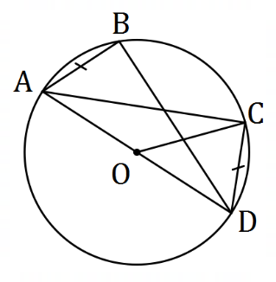

(b) Points $A, B, C$ and $D$ lie as shown on a circle  
with centre $O$ so that $AD$ is a diameter, $AB=CD$ 
 and $∠COD=42°$.

Determine the size of

(i) $∠CAD$. (1 mark)

(ii) $∠BAD$. (1 mark)

(iii) $∠CAB$. (1 mark)

(c) Two chords of a circle, $LM$ and $PQ$, intersect at $N$ so that $LM=41$ cm, $NM=20$ cm and $PQ=44$ cm. Determine all possible lengths of $QN$. (3 marks)

Question 13 (8 marks)

In triangle $OAB$, $P$ is the midpoint of $OA$ and $M$ is the midpoint of $PB$. Let $\vec{OA}=a$ and $\vec{OB}=b$.

(a) Show that $\vec{OM}=\frac{1}{4}a+\frac{1}{2}b$. (2 marks)

The position vector of $A$ is $\left(\begin{matrix}6 \\ 4\end{matrix}\right)$, position vector of $B$ is $\left(\begin{matrix}7 \\ -4\end{matrix}\right)$ and $O$ is the origin.

(b) Determine a unit vector $\hat{u}$ in the same direction as $\vec{OM}$. (2 marks)

(c) Show that $OA$ is perpendicular to $PM$. (2 marks)

(d) Determine the size of $∠AOB$. (2 marks)

Question 14 (7 marks)

(a) In trapezium $ABCD$, $AC$ and $BD$ are diagonals, and $AB$ is parallel to $CD$. Use a vector method to prove that $\vec{AC}+\vec{DB}=\vec{AB}+\vec{DC}$. (3 marks)

(b) In rectangle $OPQR$, let $\vec{OP}=p$ and $\vec{OR}=r$. Use a vector method to prove that if the diagonals $OQ$ and $PR$ are perpendicular, then $OPQR$ is a square. (4 marks)

Question 15 (6 marks)

Consider the following statement:

For two integers $a,b$ if $3a^{2}-2b^{2}$ is a multiple of $4$ then at least one of $a,b$ is even.

(a) Write the contrapositive of the statement. (1 mark)

(b) Prove that the statement is true. (5 marks)

Question 16 (8 marks)

The height of the tide, $h$ cm, of the sea above the mean level at time $t$ hours after midnight one day is given by

$$h\left(t\right)=28\cos\left(\frac{πt}{6}\right)+45\sin\left(\frac{πt}{6}\right) .$$

(a) Express $h$ in the form $a\cos{(bt-θ)}$, where $a, b>0$ and $0≤θ≤2π$. (3 marks)

(b) Determine, to the nearest minute, the time of the first high tide. (2 marks)

(c) Sketch the graph of the height of the tide on the axes below. (3 marks)

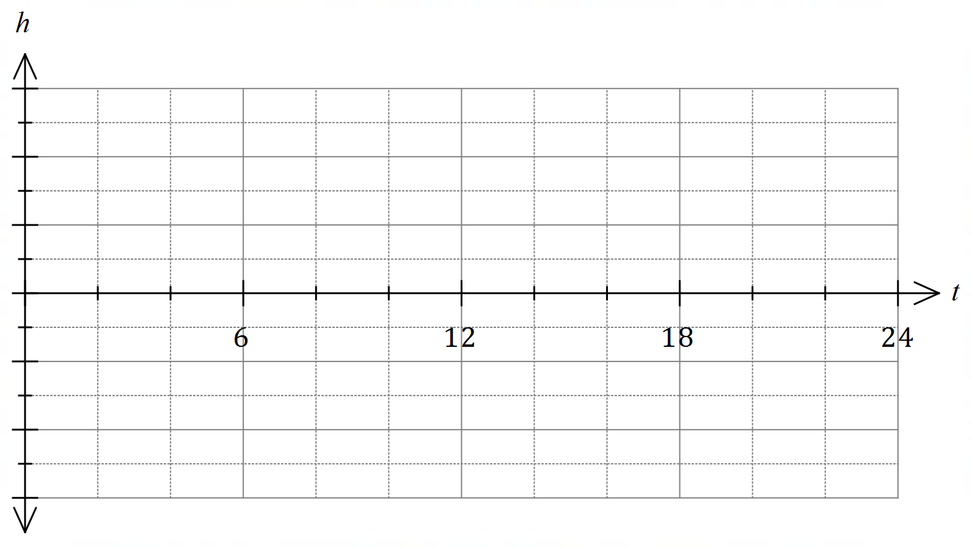

Question 17 (7 marks)

Three forces $F_{1}, F_{2}$ and $F_{3}$ act on a small body, where $F_{1}=4i-10j$ N, $F_{2}=-8i+16j$ N and $F_{3}=9i-15j$ 
 N.

(a) Determine the magnitude of the resultant force and the angle between the resultant force and the vector $i$. (3 marks)

(b) Two of the forces, $F_{2}$ and $F_{3}$, can be multiplied by scalars $λ$ and $μ$ respectively so that the three forces are in equilibrium. Determine the value of $λ$ and the value of $μ$. (4 marks)

Question 18 (7 marks)

(a) $90$ people are asked to choose two different letters from those in the word GAMBLER and write them down in order. Use the pigeonhole principle to prove that at least three people will write the same pair of letters in the same order. (3 marks)

(b) Three character codes, such as TCU, are made using three different letters chosen from the word DISCOUNT. Determine the proportion of all possible codes that start with a D or end with a T. (4 marks)

Question 19 (7 marks)

Airport B lies $170$ km due east of airport A, and in the region of the airports a wind of $25$ km/h is blowing from the northeast.

A small plane, with a cruising speed of $120$ km/h, leaves airport A. The pilot, not aware of the wind and intending to fly to airport B, steered the plane on a bearing of $090°$.

Assuming that the pilot does not realise their mistake, determine how close the plane will come to airport B if it continues to fly for several hours on the same bearing.

Question 20 (7 marks)

Triangle $ABC$ has vertices $A\left(2, 2\right), B(-4, 6)$ and $C(4, 8)$.

$ABC$ is rotated clockwise $60°$ about the origin to form triangle $A'B'C'$.

(a) Determine the coordinates of $C'$. (2 marks)

$ABC$ is reflected in the line $y=2x$ to form triangle $A''B''C''$.

(b) Determine the coordinates of $B''$. (2 marks)

(c) Determine matrix $T$ that will transform $A'B'C'$ to $A''B''C''$. (3 marks)

Question 21 (7 marks)

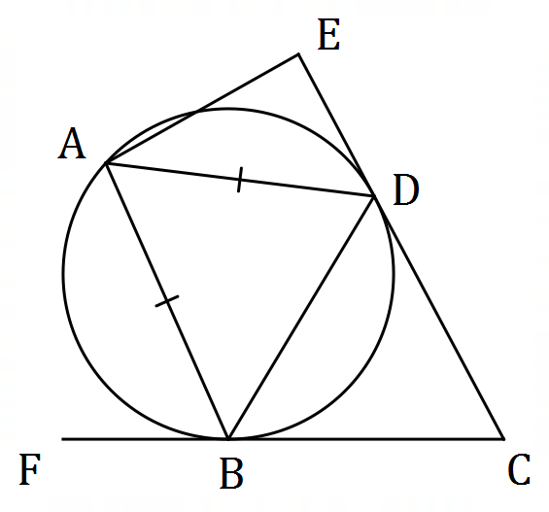The diagram, not drawn to scale, shows  
vertices $A, B$ and $D$ of an isosceles triangle  
lying on a circle so that $AD=AB$.  
  
Lines $CE$ and $CF$ are tangential to the  
circle at $D$ and $B$ respectively. $ABCE$ 
  
 is a cyclic quadrilateral.  
  
Let $∠FCE=x$.

(a) Determine, with reasons, the size of $∠AEC$ in terms of $x$. (5 marks)

(b) Hence determine the range of values for the size of $∠AEC$ in degrees. (2 marks)

Supplementary page

Question number: _________

Supplementary page

Question number: _________

© 2021 WA Exam Papers. Kennedy Baptist College has a non-exclusive licence to copy and communicate this document for non-commercial, educational use within the school. No other copying, communication or use is permitted without the express written permission of WA Exam Papers. SN245-181-2.